

HP Solution Test Bench

User Guide v 1.1

Table of Contents

Overview 3

STB General User Installation 4

Adding Print Queues to STB 8

Adding Devices to STB 10

Creating Test Scenario Example 12

Add Virtual Workers 14

Adding Activities 15

Executing STB Test Scenarios Example 20

STB Log Files 23

Troubleshooting Scenario Execution 23

# Overview

Solution Test Bench (STB) is a client-based server tool that allows testers to set up, run, and monitor automated testing of solutions running in conjunction with HP devices. STB is a client-based server tool that requires one instance of a server install and an SQL Express database.

The STB server supports one or more STB clients. The clients present a UI to the tester that allows the tester to set up, configure, and execute automated tests. Multiple clients and testers can use STB simultaneously.

The STB server includes support to manage and provide programmatic access to:

* test devices (i.e. MFPs, printers, or network scanner,)
* documents to be used in testing
* a pool of users’ credentials who serve as the actors in the execution of automated tests
* print servers and print queues that users can print to.

While not required for automated test, these features increase testing efficiency and reduce errors.

STB uses the Device Abstraction Toolkit (DAT), a SW library that allows the STB to interact transparently with a fleet of HP devices. The DAT handles the variations between different products and product families so that the tester does not need to have separate tests for different types of HP devices.

STB is designed to be used by both technicians and engineers. Engineers may decide test requirements and desired level of test coverage, while the setup, configuration, and execution of those test requirements through STB may be completed by technicians.

Users execute tests in STB through Test Scenarios. A Test Scenario allows the user to set up one or more virtual workers, who then execute a series of one or more workflows. The virtual worker can be configured using a number of variables, including, but not limited to:

* execute a set number of workflows (up to the 1000s)
* execute for a particular time duration (up to days or weeks)
* randomly execute a particular rate of workflows per time period.
* use one or several devices, including configuring several types of workers trying to use one device at the same time.

Test Scenarios and their test results are stored in the SQL database. This allows users to select and re-run previous tests, and recall test results at a later date. STB supports a variety of on demand reports.

The workflows that virtual workers can execute are determined by the set of STB Plug-Ins included in the STB package. The plug-in encodes the workflow actions and configuration options. Developers can enhance, modify, or write new plug-ins using the STB Plug-in SDK (provided separately. The STB Plug-in SDK may not be available at this time.)

In general, STB provides a setup of plug-ins for the native capabilities of the device, and for some standard office activities like printing, emailing, faxing, copying, and scanning (these may or may not be included in your STB package at this time.)

This document walks a user through the process of installing and using Solution Test Bench Client.

* **STB Client installation** - Installing one or more STB clients.
* **Configuring Test Scenarios** - Setting up one or more Test Scenarios.
* **Performing STB Test Scenarios**
* **Adding Test Documents**

There are 3 training videos that show, interactively, how to install, configure, and use STB. It is strongly recommended that users watch these videos before proceeding to the following sections of this document.

# STB General User Installation

The STB General user won’t have access to the Solution Test Bench Control Panel unless they also have Administrator rights. To install STB for the General User, complete the following steps:

1. Copy the STB installation files to the General user’s computer or virtual machine. Run the installer.
2. When prompted, click **Next** to continue with the installation.

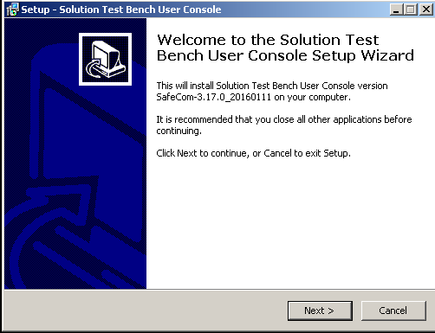  
*Fig 1.1 – STB Start Setup Window*

1. Enter the STB Server Address for the server with the completed STB Server installation.

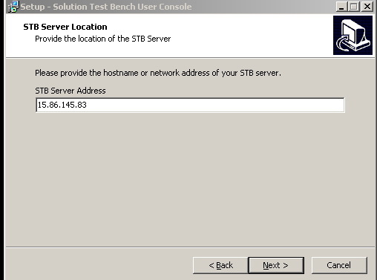  
*Fig 1.2 – STB Server Location Window*

1. Use the default by clicking next for the following: Destination Location. Click **Next**.

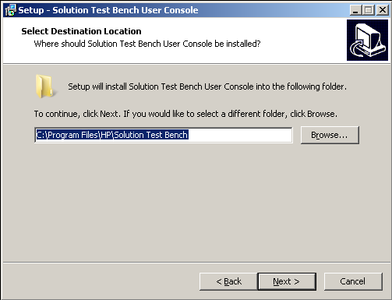  
*Fig 1.3 – STB Destination Window*

1. Use the default Start Menu Folder. Click **Next**.

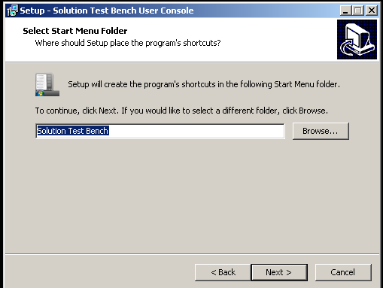  
*Fig 1.4 – STB Start Menu Icon Window*

1. When prompted, click **Install**.

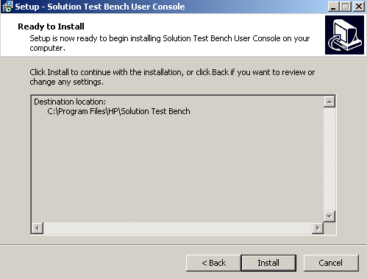  
*Fig 1.5 – STB Install Window*

1. When the installation is complete, click **Finish**.

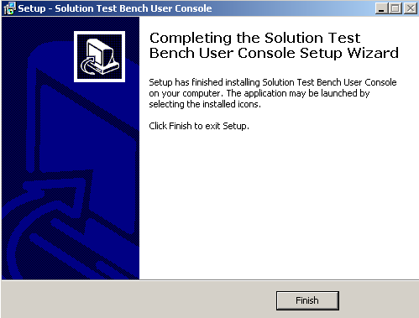  
*Fig 1.6 – STB Finish Window*

1. Locate the **Solution Test Bench** folder from the Start Menu.
2. Open the **STB User Console**.
3. Type your credentials in the **Log In** window.
   1. **Note:** Access is dependent upon the Authorized Users configured in the Server Configuration. Contact the STB administrator to get access.

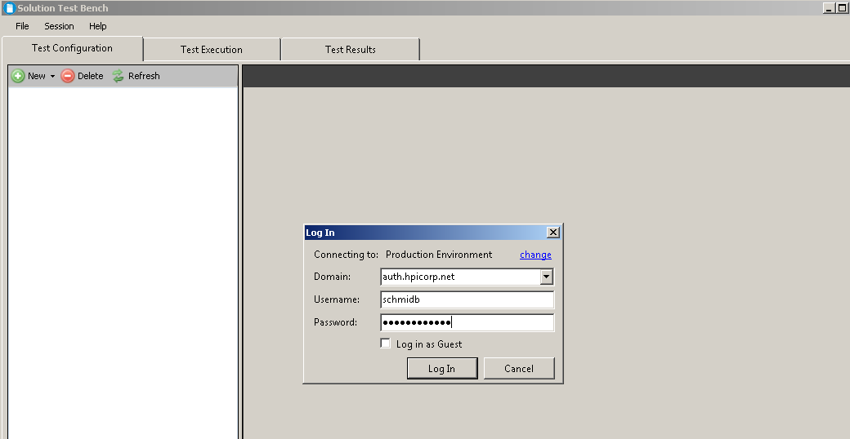  
*Fig 1.7 – STB Login Window*

# Adding Print Queues to STB

1. Launch the Admin Control Panel from  > Solution Test Bench > Admin Control Panel (OR) [C:\VirtualResource\Distribution\ControlPanel\hpstbcp.exe](../../../VirtualResource/Distribution/ControlPanel/hpstbcp.exe).
2. Under **Print Automation**, click on Print Server Inventory. You should see the following form:

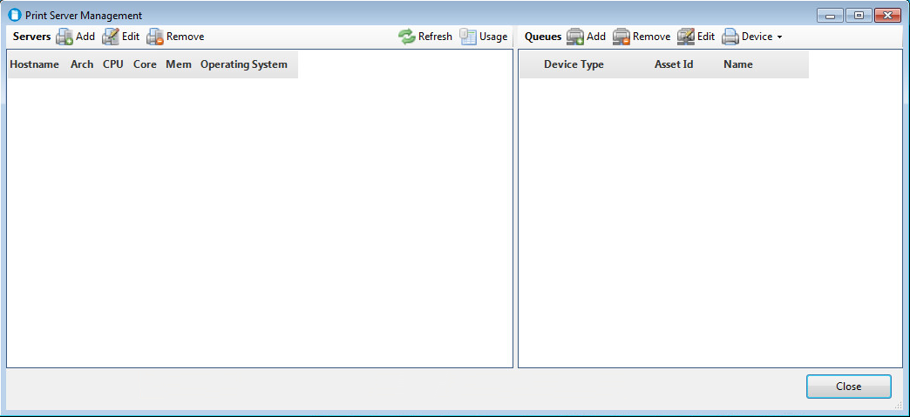

1. In the upper left quadrant next to **Servers**, click on the **Add** button.
2. Enter the host name of your Blueprint server. Note: It is assumed that your Blueprint server contains a publicly shared print queue that is monitored by the Blueprint software. Click **OK**.

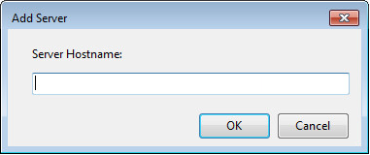

1. The software retrieves basic statistical information about the server and presents it in the following form. Make sure the Server Attributes are selected as shown. Click **OK**.

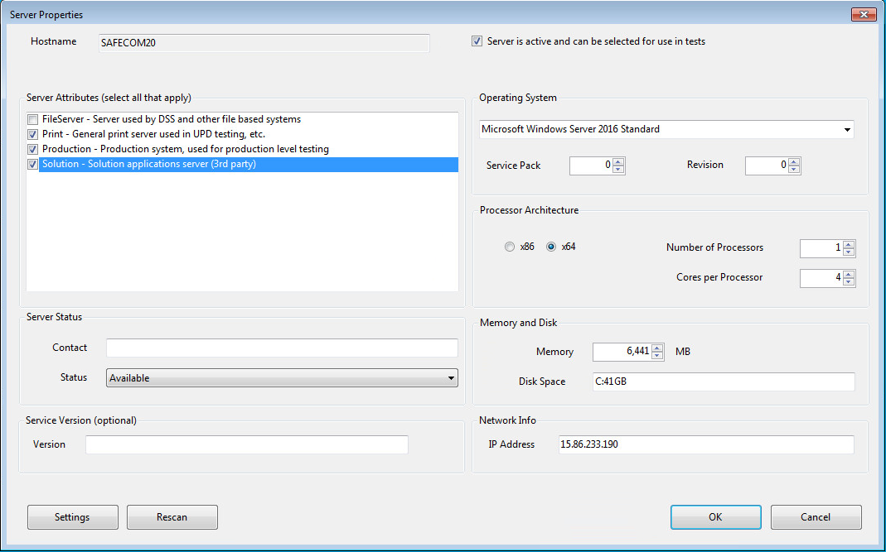

1. After the software scans the server for print queues, you should see the following message. Click **OK**

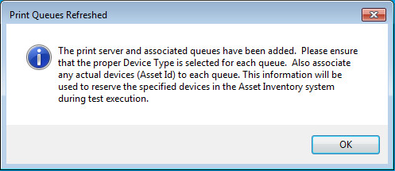

1. The Blueprint server and it’s public print queues are now added to STB. Close the form.

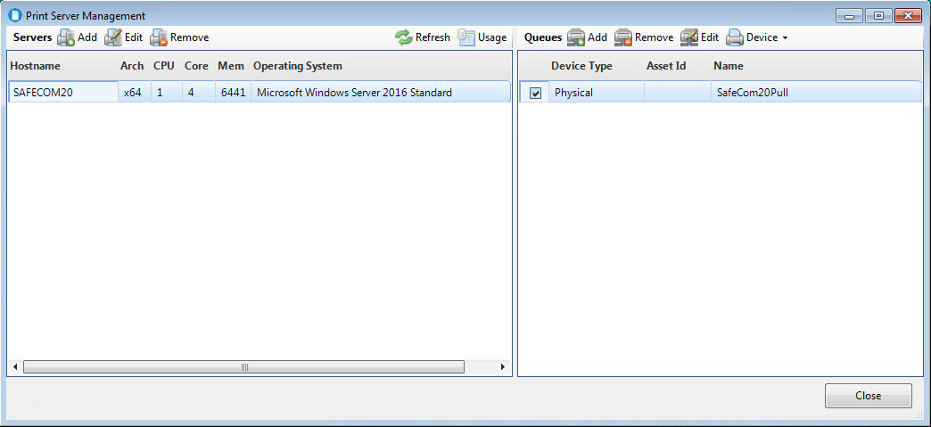

# Adding Devices to STB

1. Launch the Admin Control Panel from  > Solution Test Bench > Admin Control Panel (OR) [C:\VirtualResource\Distribution\ControlPanel\hpstbcp.exe](../../../VirtualResource/Distribution/ControlPanel/hpstbcp.exe).
2. Under **Print Automation**, click on Print Device Inventory. You should see the following form:

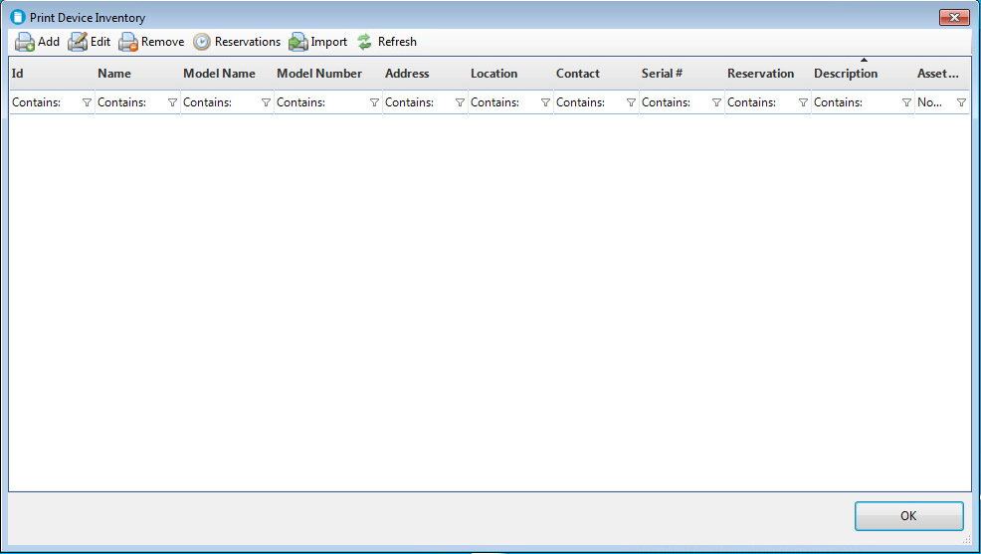

1. In the tool bar in the upper left, click on the **Add** button.
2. Enter the IP address of your test device and the device’s administrator password. Click **OK**.

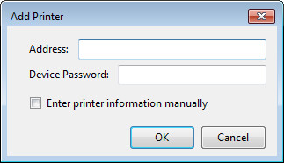

1. The software will then scan the device and present the following form. Make sure to enter a unique ID for the printer, and check the 3 capabilities at the bottom of the form as shown. Click **OK**.

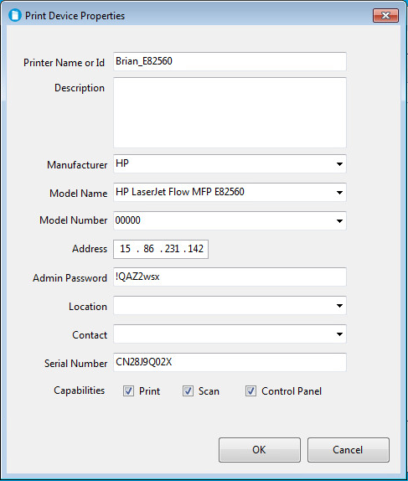

1. You will be prompted for an Inventory Pool Name. Select “DEFAULT” and click **OK**.
2. The device is now added to the Print Device Inventory. Click **OK**.

# Creating Test Scenario Example

Test scenarios are configured in the **STB User Console** of the General user’s virtual machine. Both this section and the following section Executing STB Test Scenarios Example, show how a user sets up and executes a test scenario. A sample Test Scenario is provided, with a virtual worker printing to a pull print queue, and then pull printing the document at an HP MFP.

**WARNING:** This example may not be included in your version of STB. Review these steps only as a guideline to creating your own test scenarios.

1. Open the STB user console.
2. Select the **Test Configuration** tab and right-click **Test Scenarios**.
3. Select **New** followed by **Folder**.

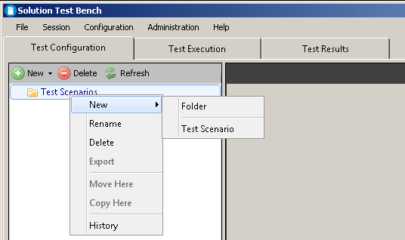  
*Fig 2.1 – Creating New Test Scenario Folders*

1. Right-click the newly created folder, select **New** and then **Test Scenario** from the slide-out menu.

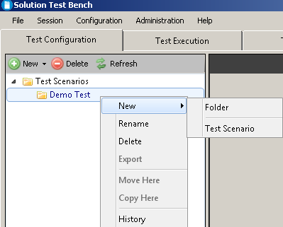  
*Fig 2.2 – Creating New Test Scenarios*

1. Type a test scenario name in the **Name** field.

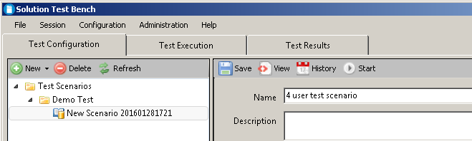  
*Fig 2.3 – Naming Test Scenarios*

## Add Virtual Workers

Add virtual workers to your scenario by:

1. Highlight the desired scenario.
2. Locate the **Scenario Virtual Resource**s section at the bottom of the page.
3. Select **Add**, then select **Solution Tester** to open the **Virtual Resource Configuration** window**.**

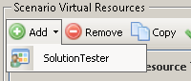  
*Fig 2.4 – Adding Solution Tester*

1. Type a name for the virtual worker in the Name field.
2. Type the number of test iterations for this virtual worker to repeat the activity.

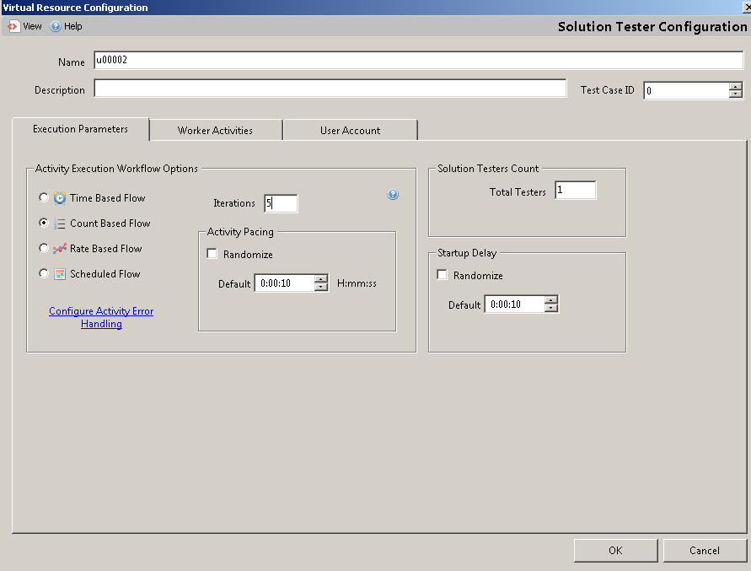  
*Fig 2.5 – Adding Test Iterations*

## Adding Activities

1. Select the **Worker Activities** tab.
2. Select **Add** from the **Main Activities** tab.
3. Select **PullPrinting** from the drop down menu.

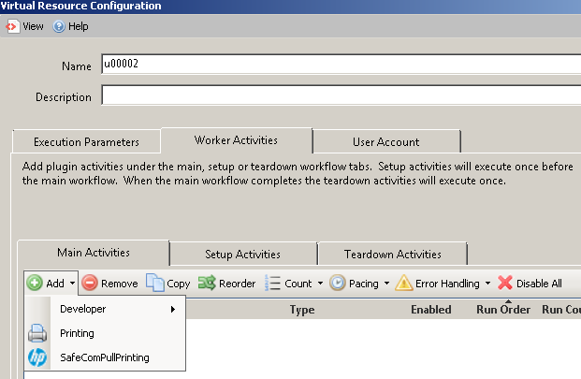  
*Fig 2.6 – Adding Solution Tester*

1. Type a name to identify the activity in the **Activity Name** field.
2. Select the desired document or documents from the **Document Selection** section.

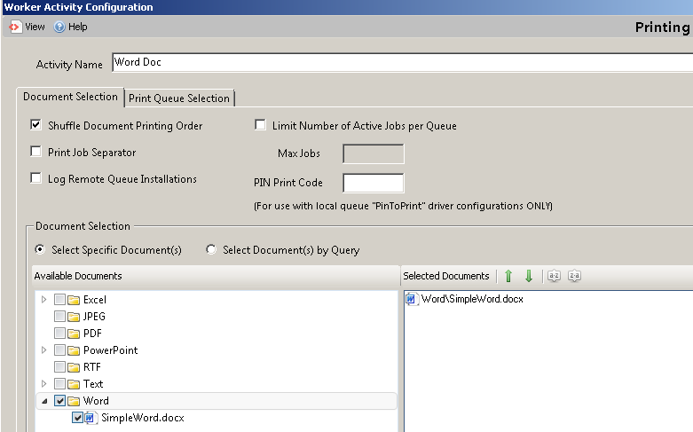  
*Fig 2.7 – Adding Activities And Documents*

1. Select the **Print Queue Selection** tab.
2. Select **Add/Remove** from the **Remote Queue** drop down box to display the **Remote Print Queue Selection** window.

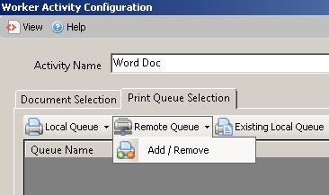  
*Fig 2.8 – Print Queue Selection*

1. Select the desired print queue or print queues.
2. Select **OK**.
3. Select **OK** to close Printing Configuration window and return to the **Worker Activities** tab.

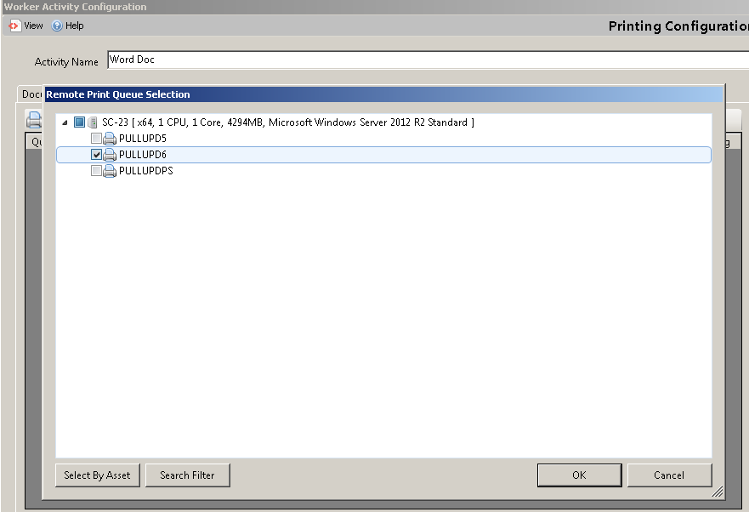  
*Fig 2.9 – Remote Print Queue Selection*

1. Select **Add** from the **Main Activities** tab.
2. Select **PullPrinting** from the drop down menu to open **Device Selection**.

  
*Fig 2.10 – Remote PullPrint Selection*

1. Type a name that identifies the activity into the **Activity Name** field.
2. Select **Add Device** from the **Device Configuration** section.
3. Highlight the desired **device** and click **Select**.

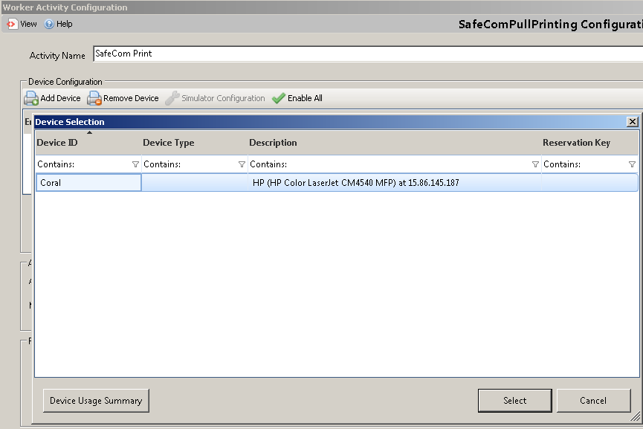  
*Fig 2.11 – Device Selection*

1. Select **Sign In**.
2. Select desired activity from **Pull Print Configuration** menu.
3. Press **OK**.

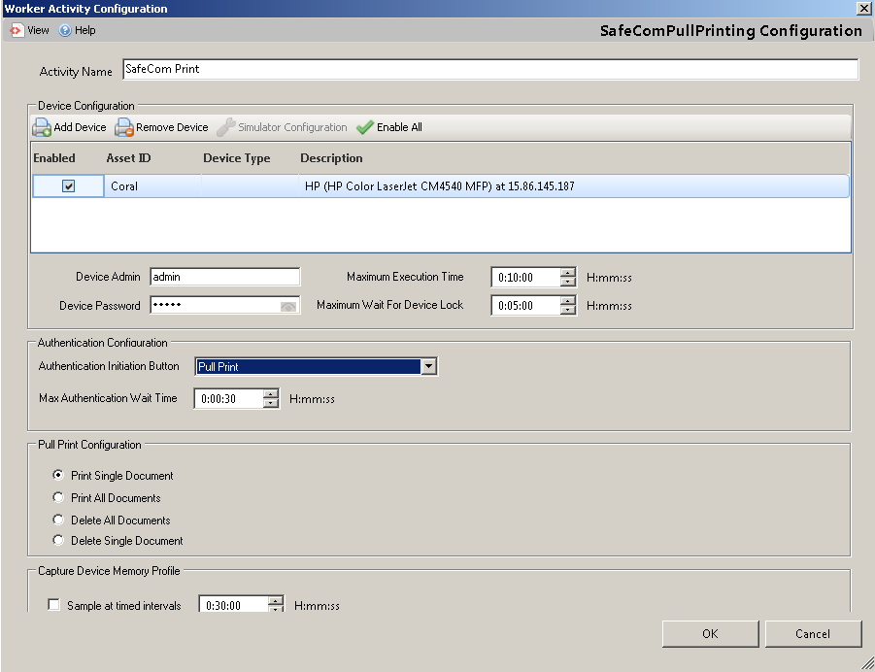  
*Fig 2.12 – Activity Selection*

1. Verify that the activities are in the desired **Run Order.** 
   1. If out of order, use the navigation arrows on the right to change the Activity order. Click **OK**.

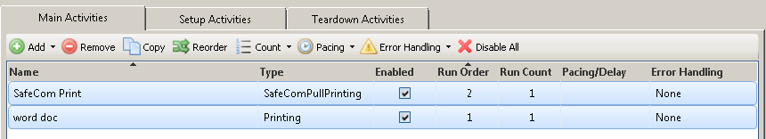  
*Fig 2.13 – Run Order Selection*

1. Select the **User Account** tab.
2. Select **Provide manually entered user account information to each activity** option.
3. Fill in the fields with pertinent information for an active directory user.
4. Select **Run the Solution Tester process using the same account selected above**.

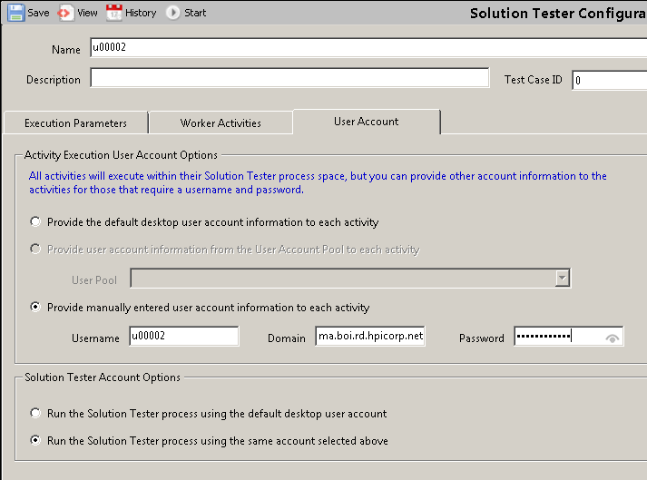  
*Fig 2.14 – User Account Information*

1. Select the **Workers Activity** tab.
2. Change the **Activity Execution Mode** to **Ordered**.
3. Select **Save** to save the settings configured for this user.

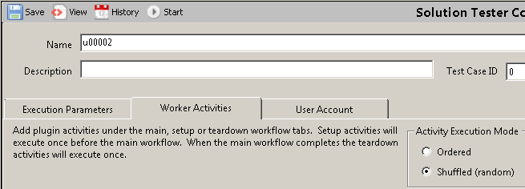  
*Fig 2.13 – Change Activity Order*

1. To add more Virtual Workers to the scenario, return to Adding Virtual Workers.

# Executing STB Test Scenarios Example

Complete the following steps to execute a STB Test Scenario:

1. Highlight the desired scenario and click **Start**.

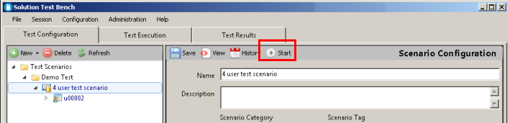  
*Fig 3.1 – Start Test Scenario*

1. Select an appropriate **Estimated Runtime**.
2. Click **Next**.

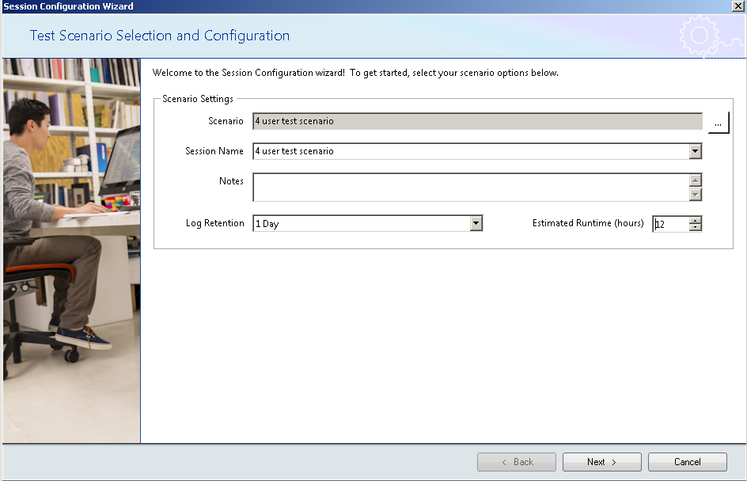  
*Fig 3.2 – Select Runtime*

1. Select the device being used.
2. Click **Next** to proceed.
   1. **Note:** Paperless mode is selected by default. This option must be deselected if physical pages need to be printed.

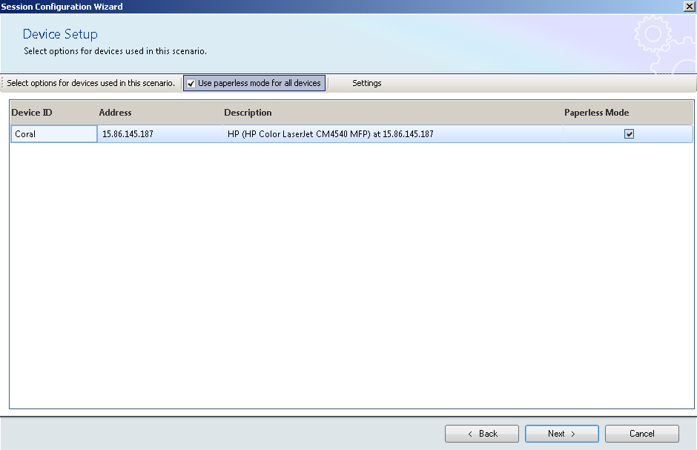  
*Fig 3.3 – Select Device to be used*

1. Click **Start Session**.

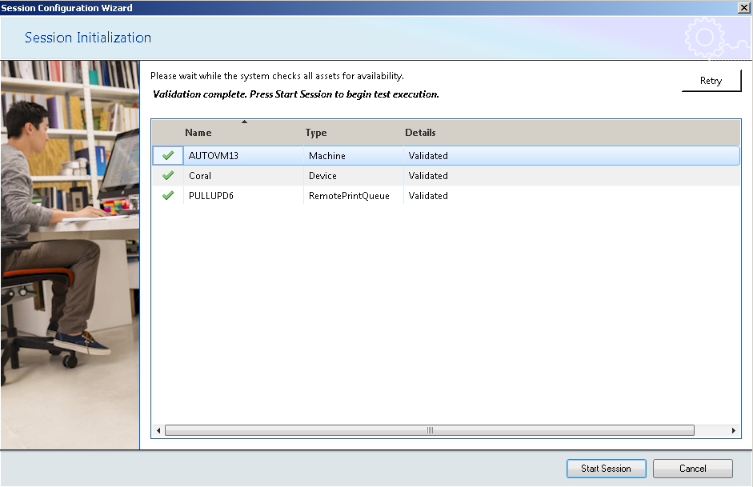  
*Fig 3.4 – Starting Sessions*

1. The **Virtual Worker Console** is minimized to the windows task bar. Maximize this window.

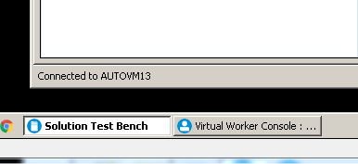  
*Fig 3.5 – Maximize Output Window*

1. When the testing has finished for that user the Execution Status will show **Finished**.
   1. **Note:** The log can be viewed by clicking **View Log**.

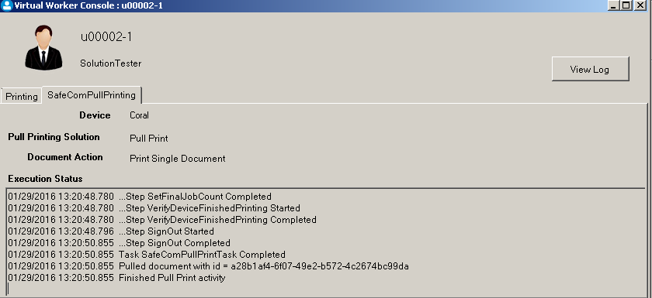  
*Fig 3.6 – Virtual Worker Console*

1. Return to the **Test Execution** Tab. Session will show Complete.
2. Select **End Session** to end or execute another session.

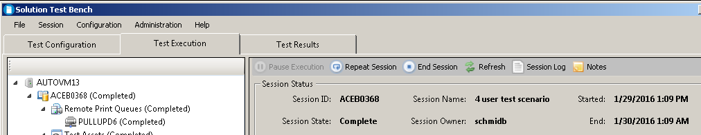  
*Fig 3.7 – Session Complete Window*

# STB Log Files

All STB executing processes create log files. The log files can be very helpful in troubleshooting and are essential to the support process. When contacting HP about STB related issues, you can expect to be asked for the STB log files. The log files can be found at the following locations:

STB Console

C:\VirtualResource\Distribution\STBUserConsole\Logs

STB User Processes

C:\VirtualResource\Distribution\SolutionTesterConsole

STB Data Service

C:\VirtualResource\Distribution\DataService\Logs

# Troubleshooting Scenario Execution

This document recommends the use of User Pools when executing a scenario (see section “Running the Scenario”, step #1). When a scenario first runs in a new environment, it is common to experience errors related to user permissions regarding the user pools. There are several different permissions related errors that could be seen.

Impersonation

STB starts each user process using impersonation. Impersonation is the ability of a thread to execute other threads (or processes) using different security information than the process that owns the thread. The STB User Console executes as the currently logged-in user. When STB starts a new session, it creates new user processes (using the user configuration information from the user pools) by impersonating the users as themselves. In order for the impersonation operation to work, the currently logged-in user MUST have local administrator permissions on the machine where STB is executing. This is the first thing to check if you are experiencing errors during session startup.

Local Administrators

During testing, a user process may need to copy test documents, rename test documents, and remove the copies of the test documents during test execution. To ensure the user process has the permissions to execute all of that on the local machine, STB adds each user in the user pool to the local Administrators group. Part of the process of adding the users in the user pool to the Administrators group is to retrieve the list of all users that currently are members of the Administrators group. Sometimes there are domain users that are members of the local Administrators group that the currently executing user process does not have permissions to view. Remember that the currently logged in user needs to be a local Administrator. Local Administrator permissions does NOT grant permissions to view information about domain users. So, if the machine upon which STB is executing contains domain users in it’s Administrators group, this may be the cause of the startup errors. In this case, the specific error that is generated is:

COMException (0x80070035): The network path was not found.

You may not actually see the text of this error in an error message, but if you check the log file for the STB User Console, you can find this error logged there. If you find this error message in the STB User Console log file, check the Administrators group on the machine where STB is executing and remove any domain users you suspect the currently logged-in user may not have permissions to view. Even if the currently logged-in user SHOULD have permissions to view the domain users, it may resolve the startup issues by removing those users from the local Administrators group.

In summary, if you are experiencing session startup issues, try the following:

1. Check the STB User Console log file for errors related to startup. Errors related to starting up a user process, or permissions errors, or “The network path was not found” are good candidates for the issues described in this section.
2. Check the local Administrators group for the currently logged-in user and add it, if it is not already there.
3. Check the log file for “The network path was not found.” and remove other domain users from the local Administrators group if this error is present in the log file.

Error Communicating with Session Proxy for <Session Id>

The STB User Console communicates with other STB data services when starting a new session. If an error is encountered by any one of the data services, the following message is returned: “Error communicating with session proxy for <Session Id>”. This is a top-level message that means that something went wrong in the service. To get more information about what went wrong, click on the “Details” button in the error message pop-up:

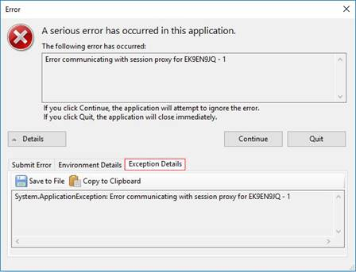

This action will display additional tabs regarding the error that occurred. Click on “Exception Details” to get more information about the error that occurred in the data service.

Insufficient Domain Accounts

One of the errors you may see (in the Exception Details tab) when your test fails to start properly is related to not having enough domain accounts available in the domain account pool.

Reserve::Error communicating with session proxy for EK8PYRYE - 1

System.AggregateException: One or more errors occurred. ---> HP.ScalableTest.Framework.Dispatcher.InsufficientDomainAccountsException: There were not enough domain accounts available to run this scenario. PoolName Test, Number Requested: 4

at HP.ScalableTest.Framework.Dispatcher.DomainAccountService.ReserveBlock(AssetInventoryContext context, String sessionId, DomainAccountPool accountPool, Int32 size)...

Whenever there aren’t enough domain users for a test, MOST of the time the cause is because a previous reservation did not get cleaned up. If you see the error message above, click **Continue** in the error popup screen, then stop the test.

* In STB, select the **Administration** menu item and click **Virtual Worker Account Pools**.
* Select the account pool you wish to view, and click on the **Reservations** button:

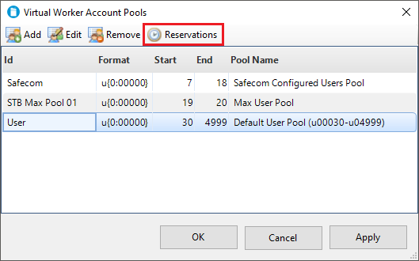

* The reservation will display in the popup screen. If the session is not in a “Running” state, the reservation can be removed by clicking the **Remove** toolbar button.

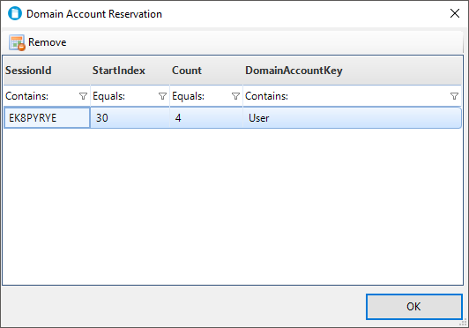

After removing the domain account reservation, you should be able to start your test.

In summary, when you encounter the error that there aren’t enough Virtual Users to run your scenario:

* Check the **Exception Details** tab on the Error dialog for additional information about what caused the error. You’ll have to parse through code stack trace data, but it will be in there somewhere. Look for “InsufficientDomainAccountsException” in the stack trace.
* If the error was InsufficientDomainAccountsException, open the Virtual Worker Account Pools utility to view the Virtual Worker Account reservations.
* Remove any reservations tied to sessions that are no longer running.